**Setup Guide of RFID Reader to RFID Device Management Tool V4.43**

1. Take a RFID reader where you find bunch of colourful wires as in figure below.

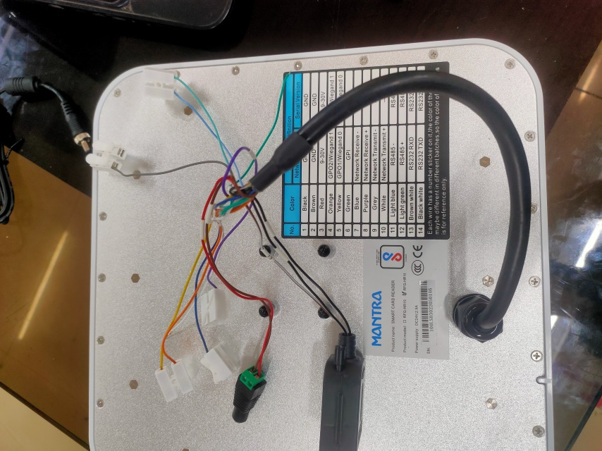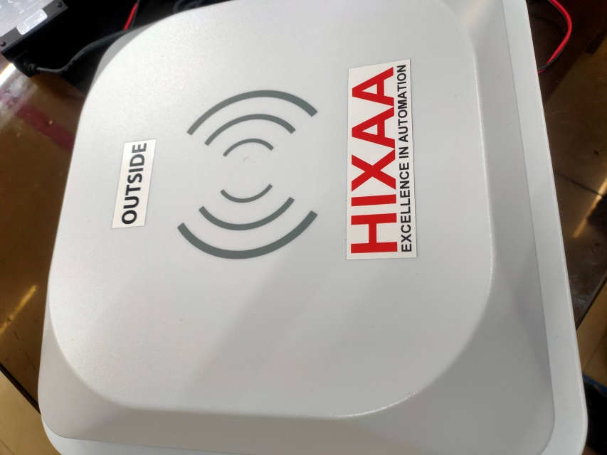

Fig. Back

Fig. Front

2. From these bunch of colourful wires , pick two pairs of wires which is going to be used in the configuration of RFID reader.

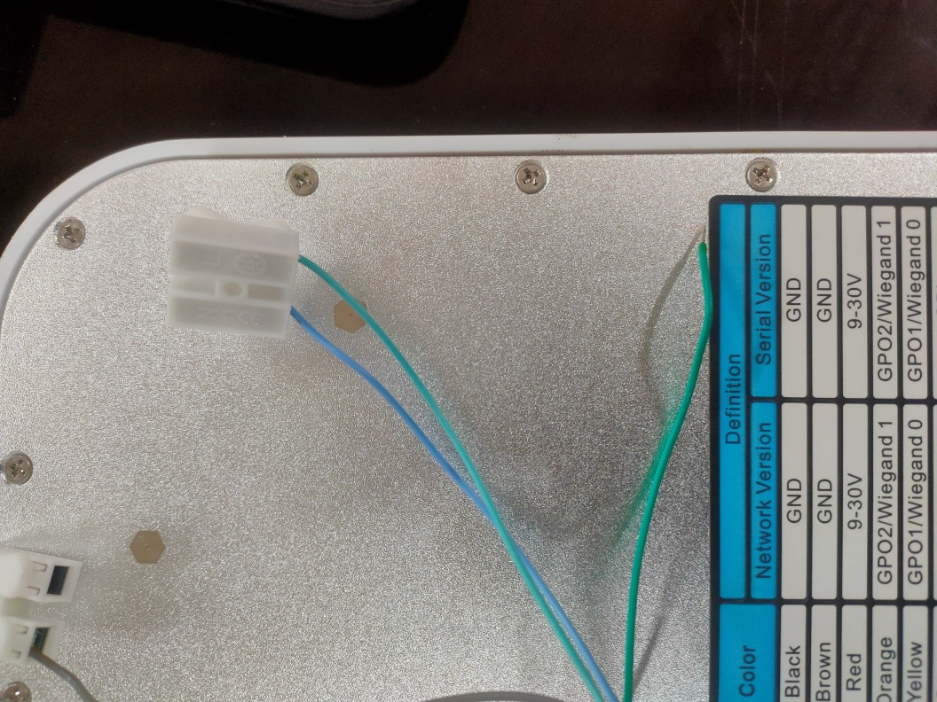

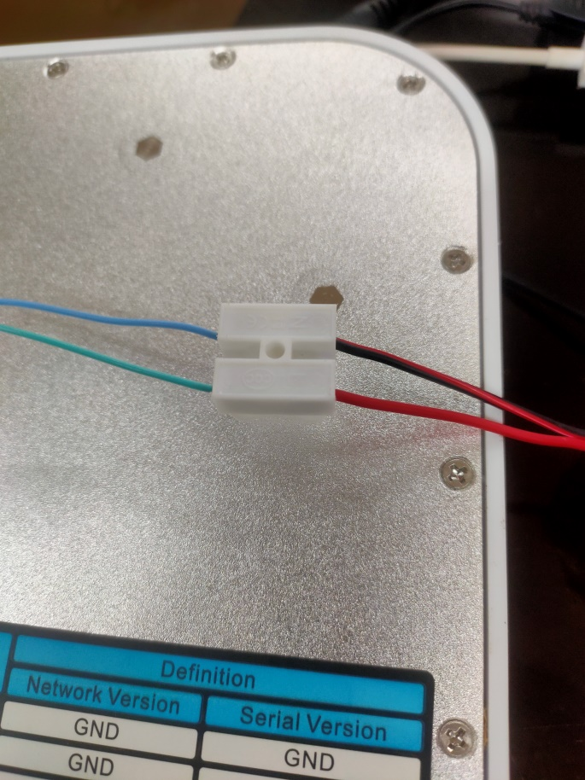2.1 In the above cropped box, there is light green wire which should be connected with (+ve) and light blue wire should be connected with (-ve) of RS485 dongle connector as you can see in figure below.

Light blue (-ve)

Light green (+ve)

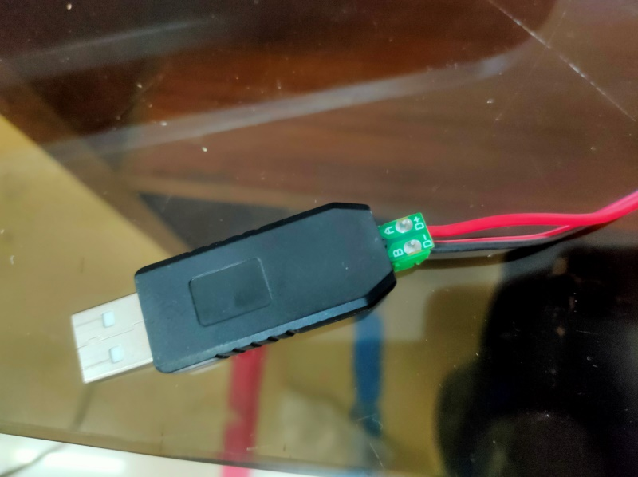

Fig. RS485 dongle connection with RFID Reader

2.2 Now the next pair of wires we need to connect i.e. power cable or VCC & Ground of RFID to the 24V adapter (you can use any adapter in between of 9V to 24) as shown in figure below. In the 1st figure, there is power connector in which red wire is VCC(+ve) & brown wire is Ground(-ve). While in second figure, the adapter has been connected with the power connector of RFID reader.

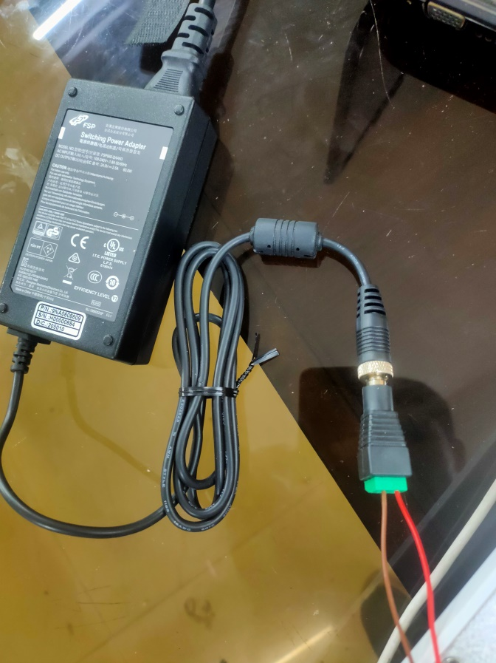

Fig. Connection power connector and adapter

Red wire(VCC / +ve)

Brown wire(GND / -ve)

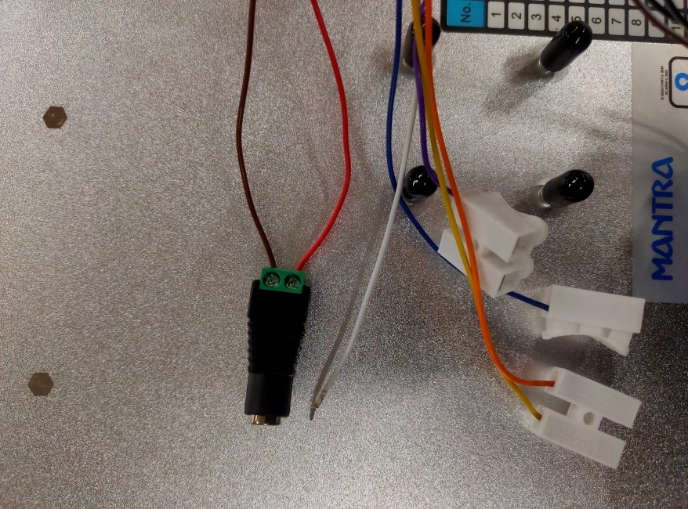

Fig. Power connector of RFID reader

3. Now, power up the RFID by using adapter; after getting successfully powered up you will hear a beep from RFID.

4. Start the RFID device management tool V4.43 software in your PC. And, then RS485 dongle to the laptop. The interface of the software would be as shown in figure below.

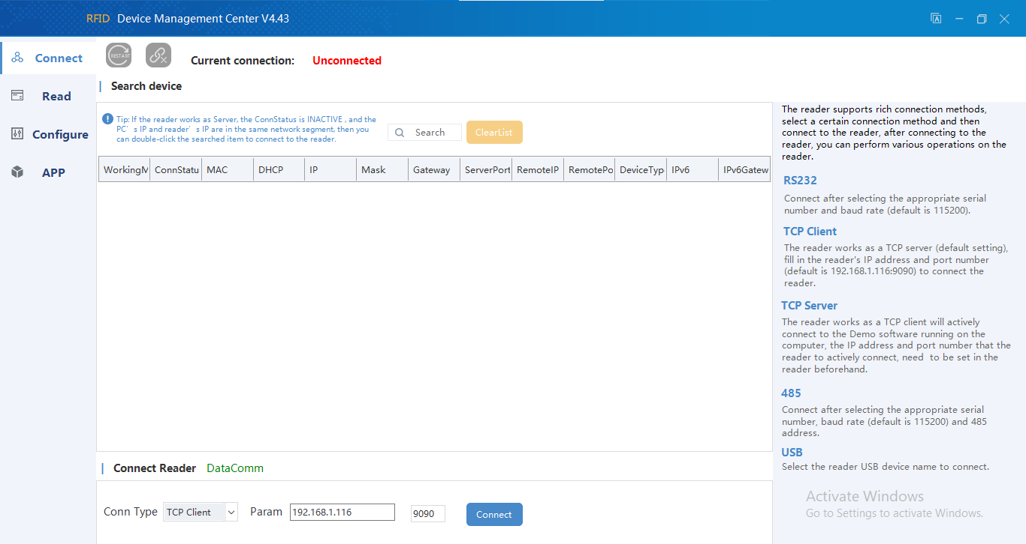

5. In the interface of RFID Reader tool, in the left bottom corner you will find **Connect Reader.** You need to always set this in **DataComm** mode.

6. Below of this Connect Reader option, there is **Conn Type** which need to be set as **RS485** because we are using RS485 wire for connectivity purpose.

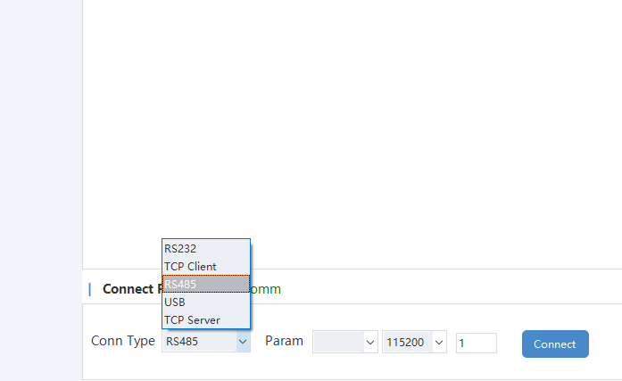

7. Beside of this, there are **Param** which will be a port name of your laptop(ex. **COM3** in our case) and **baud rate** is always need to be set at **115200**.

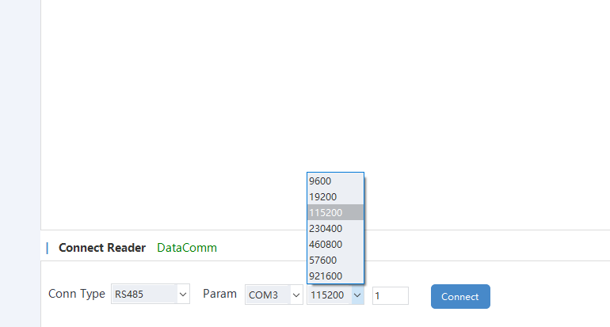

8. Now you are all set to connect the RFID reader to the RFID reader tool. Hit the Connect button. You will a see a dialogue box of message “*Connected successfully*.”

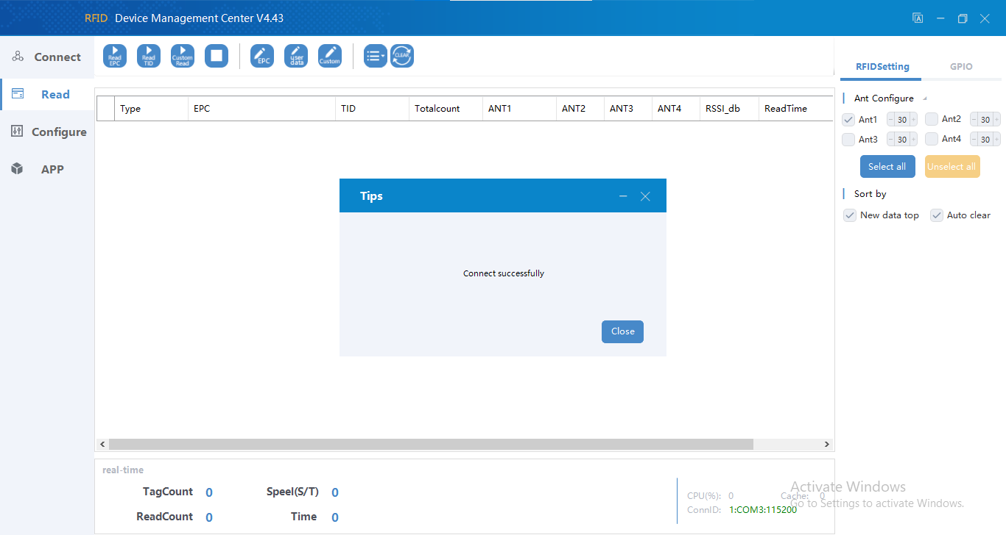

Tip: But there might be a case where you will find that “*Connection failed*” in a dialogue box. There are some things mentioned below which you need to do during this situation;

a. Check the Serial Com setting of your PC/ Laptop where baud rate should be set as 115200. Right Click on Start Menu-> Device Manager -> Ports -> Select the Port & Check its properties.

b. Never plug the RS485 dongle before powering up the RFID reader. RFID reader won’t read the PORT sometimes.

9. After getting connected successfully, you need to first STOP the service from Navigation Panel -> Read -> STOP(RFID reader stop reading or detecting the RFID tags).

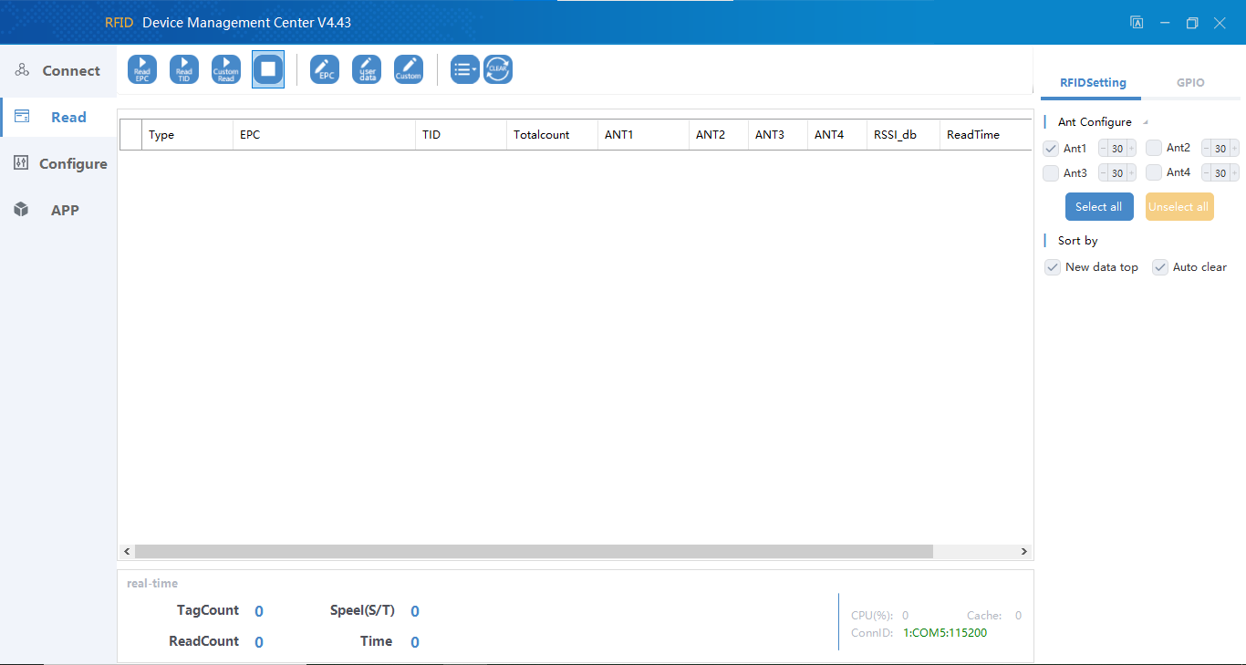

STOP

10. Now you’re ready to configure. Go to configure menu. And, then go to the **RFID settings**. You will find an interface as given below.

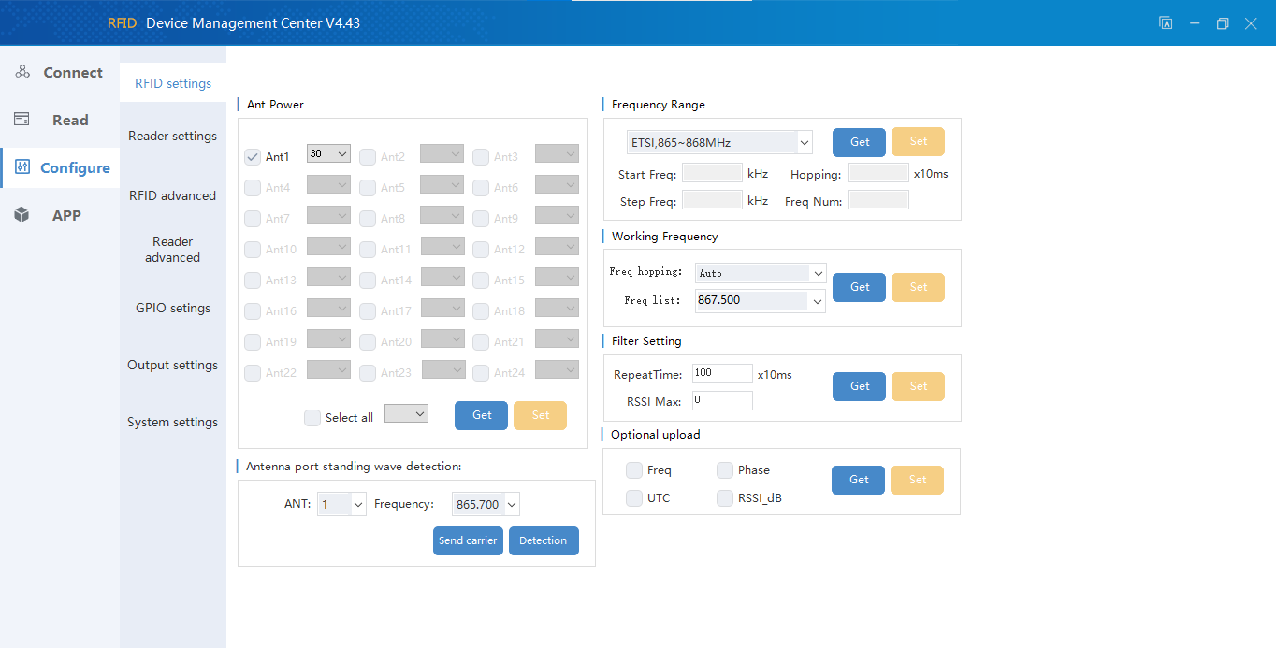

Here you need to set some parameters such as:

|  |  |
| --- | --- |
| Ant Power(Antenna Power) | 30 |
| Frequency range | ETSI, 865 ~868 MHZ |
| Frequency hoping | Auto |
| Frequency list | 867.500 |
| Repeat time | 100x10 ms |

After substituting these values, every time you need to press the **set button**.

Tip: When you will set the values for parameters given there, for every successful entry it will show the dialogue box which consists **“0|OK”.**

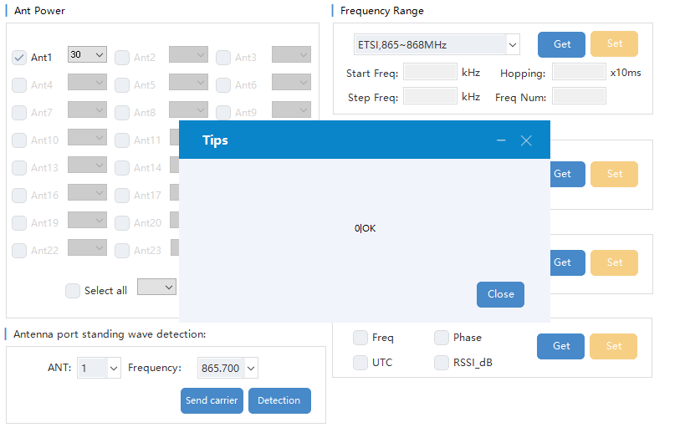

11. Now go into **Reader setting**, where just go to RS485 section and click **GET button** and it automatically fetch the baudrate at which you have connected the RFID reader.

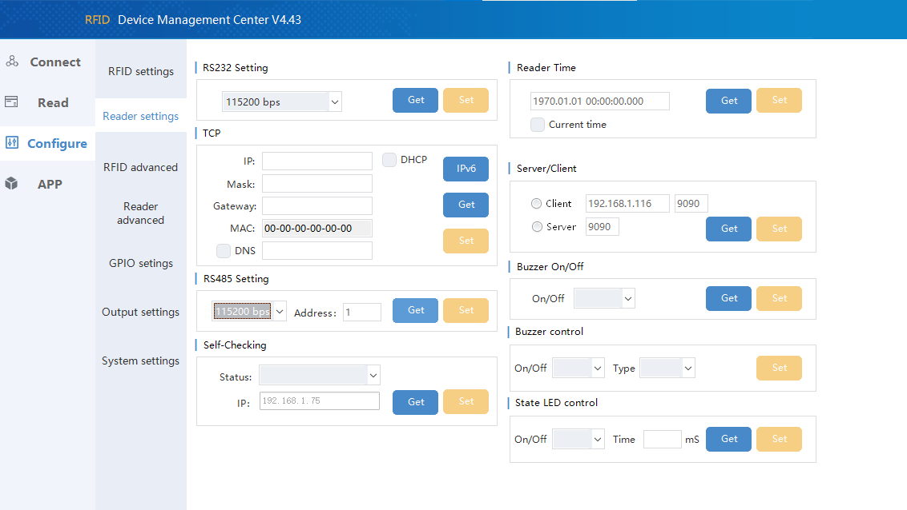

12. Next go to the **GPIO settings**, where set the parameter’s values as set in picture below and then click **Set button.** If it is done successfully, the dialogue box will be there with message of **“0|OK”.**

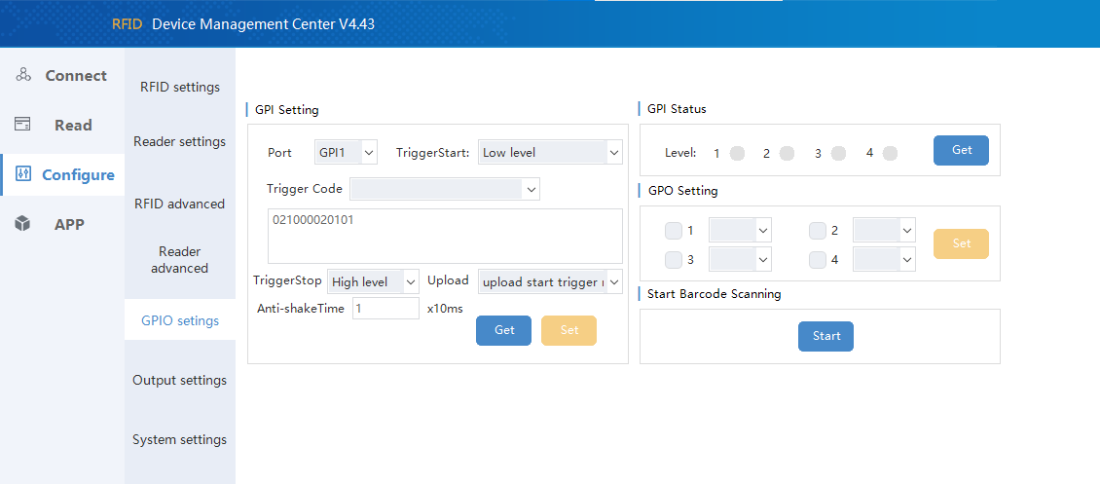

13. Now the main section of this configuration is Output settings. The specific address of a RFID tag will get displayed by using RFID reader on Serial Com Port. Here, we have specified the RFID readers with the start data of I_(Inside Reader) and O_(Outside Reader). If the RFID tag get scanned by Inside Reader, it will parse the tag address starting with I_ followed by its unique address which determines the RFID tag is inside the room. On the other hand if that same tag get scanned by Outside Reader, it will parse the tag address starting with O_ which determines RFID tag is outside the room.

**For INSIDE Reader:**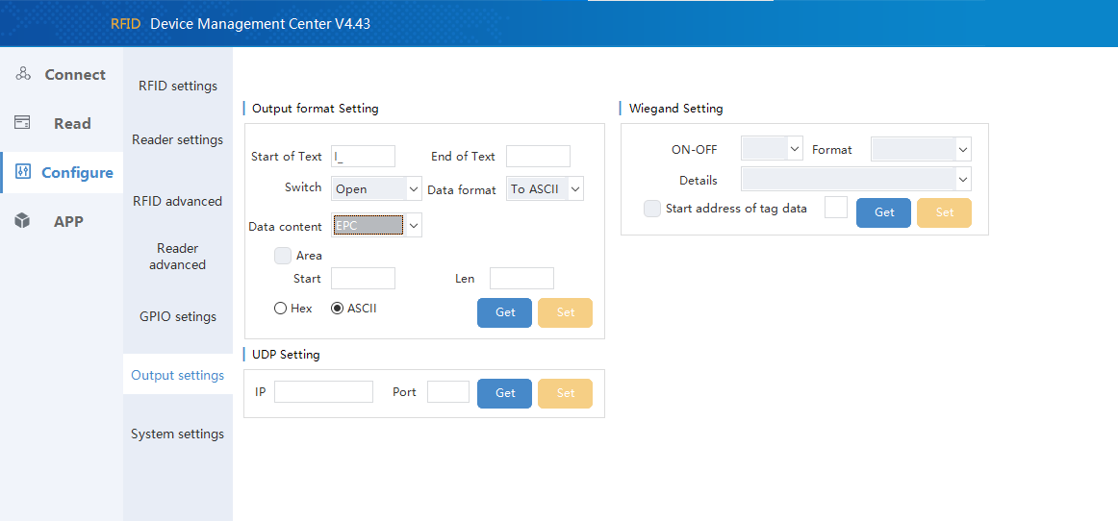

Here, parameters should be set as mentioned below;

**Start of Text**: I_

**Switch**: Open

**Data format**: To ASCII

**Data Content**: EPC

And, from Hex and ASCII -> select **ASCII**. Then, click the Set button which will show a message of “0|OK”.

Then we need to set the data in Hex form. The steps to set the data in Hex form is given below;

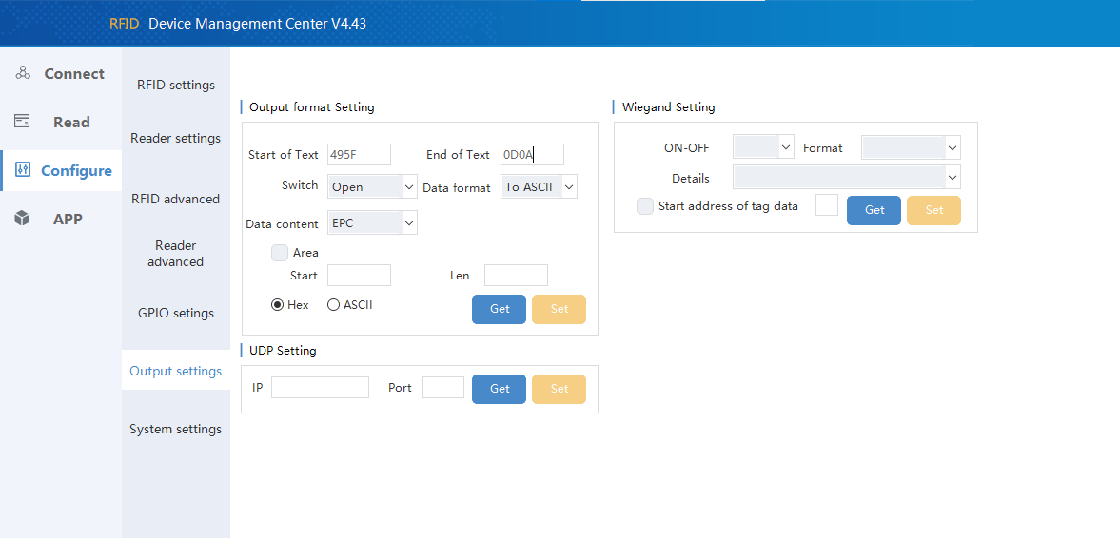

Now, this time select **Hex** from Hex and ASCII which automatically convert the start data into Hex form(eg. I_ in hex form is 495F). Then, set the End of Text with **0D0A**. And, leave the other parameters as it was set already. Click the **Set button**.

And, that’s how RFID reader configured as an **Inside Reader**.

**For OUTSIDE Reader:**  Repeat the same as we did in previous process of configuration of Inside reader. Just replace the I_ with **O_** as we are configuring this reader as **Outside reader**.

Tip: The switching from **ASCII to Hex** should be done in same sequence as done in previous process.

14. So, we are done with configuration part. Now we have to check whether the data is coming or not with successful specification of **I_** and **O_**. For this we are going to run a **python script** on the command prompt (Windows +R). A python script is given below:

import serial

ser = serial.Serial("COM3", 115200, parity = serial.PARITY_NONE, timeout = 0.01)

# ser.write(bytearray(b'AA 02 10 00 02 01 01 71 AD'))

ser.write(serial.to_bytes([0xAA, 0x02, 0x10, 0x00, 0x02, 0x01, 0x01, 0x71, 0xAD])) # type: ignore

while True:

data = ser.readline()

# data = str(data)

# print(type(data))

# print(data[2:-5])

print(data.decode(errors='ignore'))

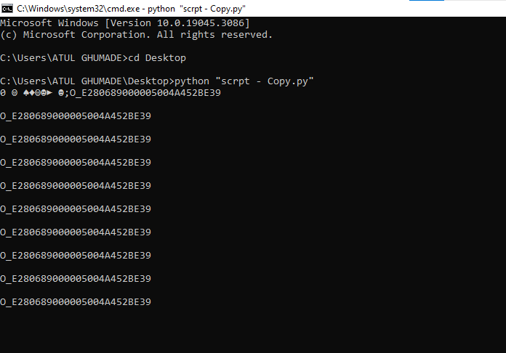The output is coming in command prompt as shown in figure below. This time we are using **Outside Reader** because of which we are getting data in format of **O_** followed by tag address.

If we would have scan the tag using **Inside Reader** , the output on the command prompt would be starting **I_** followed by tag address.